**M.I.T. LAB Assignment – 04**

**U19CS012**

(1) Write a program to check the 4th bit of 8-numbers stored from location 2000H.

Notepad Code:

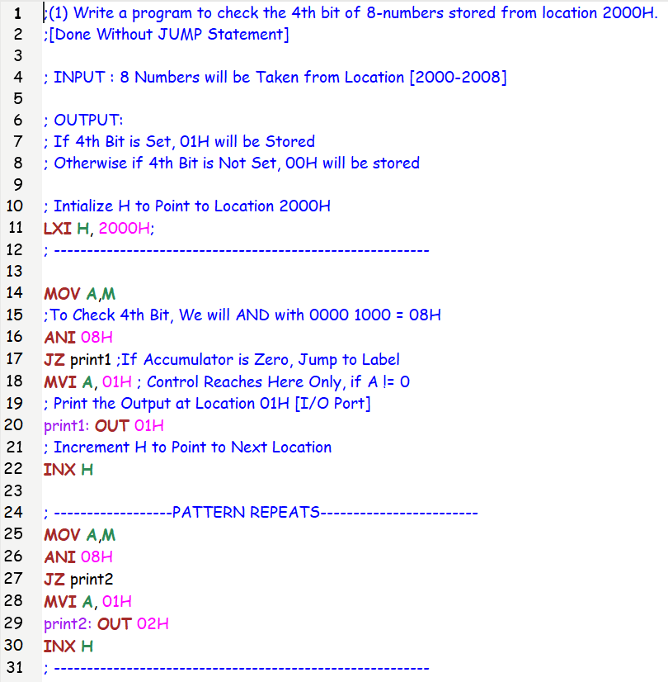

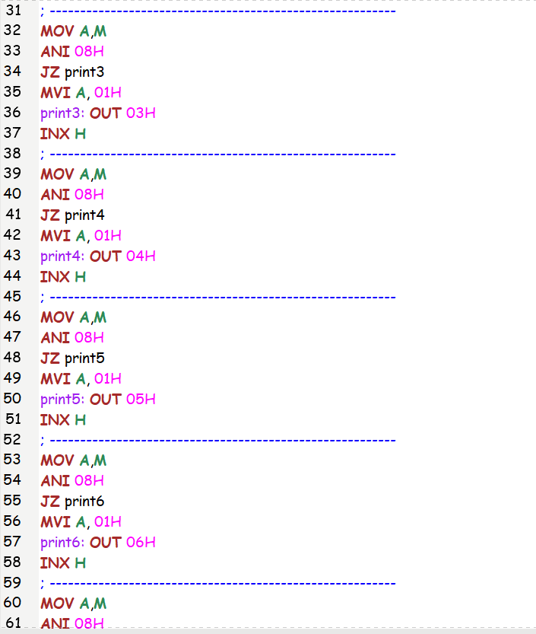

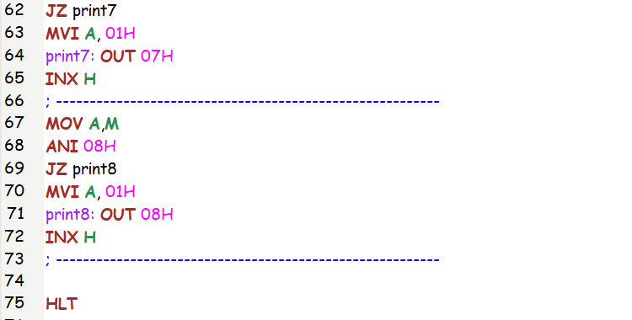

Registers and Memory:

|  |  |  |  |  |  |  |
| --- | --- | --- | --- | --- | --- | --- |
| Location | Hexadecimal | Decimal | Binary | Location | 4th Bit | Output |
| 2000H | 1C | 28 | 0001 **1**100 | 3000H | 1 | 1 |
| 2001H | 7A | 122 | 0111 **1**010 | 3001H | 1 | 1 |
| 2002H | 65 | 101 | 0110 **0**101 | 3002H | 0 | 0 |
| 2003H | B7 | 183 | 1011 **0**111 | 3003H | 0 | 0 |
| 2004H | 4E | 78 | 0100 **1**110 | 3004H | 1 | 1 |
| 2005H | 18 | 24 | 0001 **1**000 | 3005H | 1 | 1 |
| 2006H | 34 | 52 | 0011 **0**100 | 3006H | 0 | 0 |
| 2007H | 57 | 87 | 0101 **0**111 | 3007H | 0 | 0 |

INPUT OUTPUT

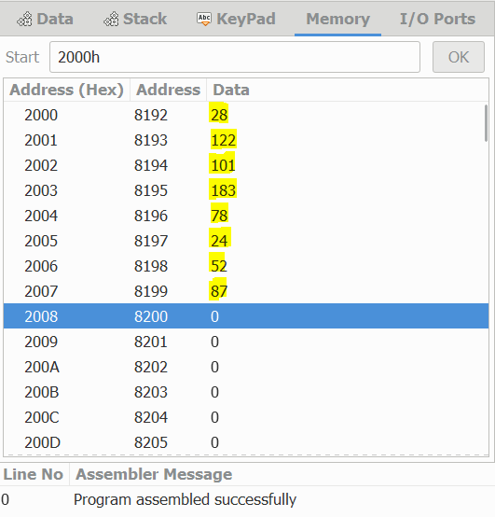 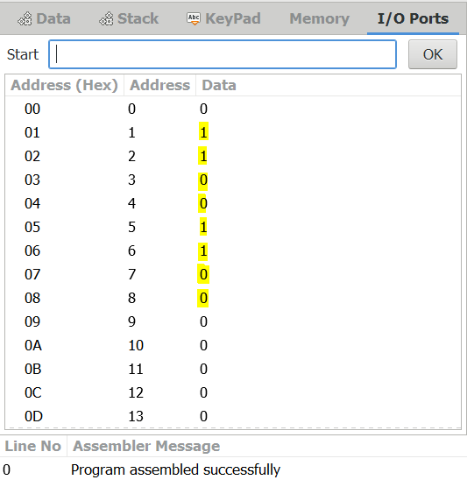

(2) Write a program to swap lower 4 bit nibble with upper 4 bit nibble of 8 bit data at memory location 2100H and place a result to location 2101H.

Notepad Code:

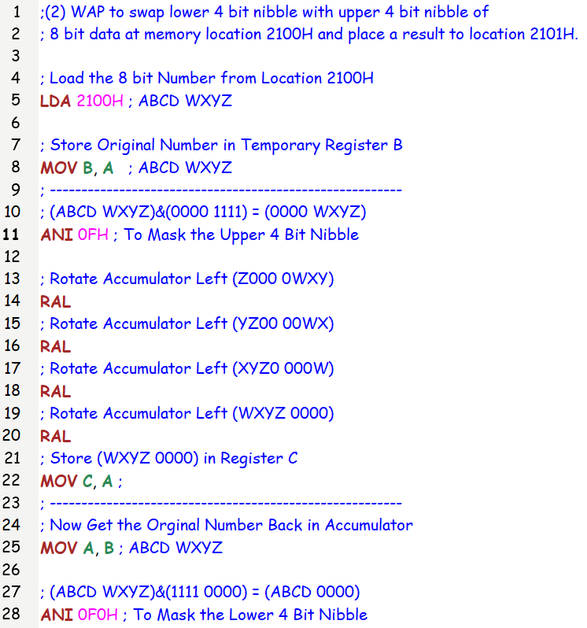

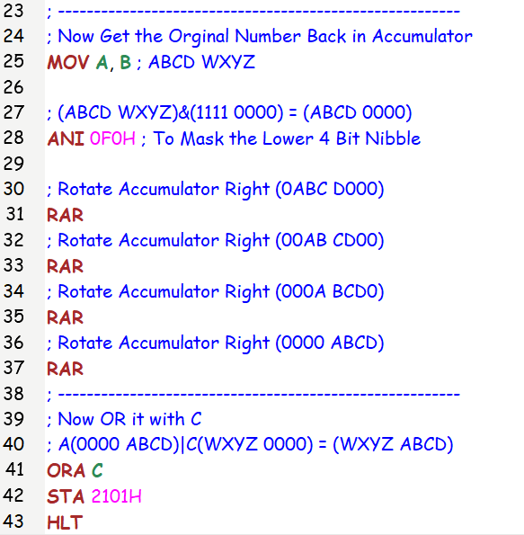

Registers and Memory:

|  |  |  |  |  |  |
| --- | --- | --- | --- | --- | --- |
| Location | Hexadecimal | Decimal | Location | Hexadecimal | Output |
| 2100H | 1C | 28 | 2101H | C1 | 193 |
| 2100H | 7A | 122 | 2101H | A7 | 167 |
| 2100H | 65 | 101 | 2101H | 56 | 86 |
| 2100H | B7 | 183 | 2101H | 7B | 123 |
| 2100H | 4E | 78 | 2101H | E4 | 228 |

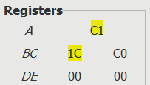 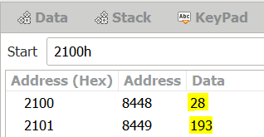

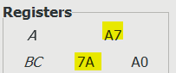 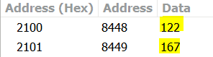

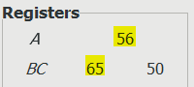 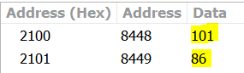

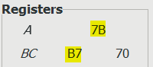 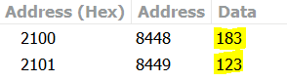

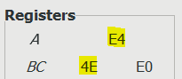 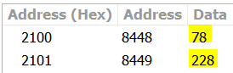

(3) Write a Program to shift a 16-bit data 1 bit left. Assume data is in the HL register pair

Notepad Code:

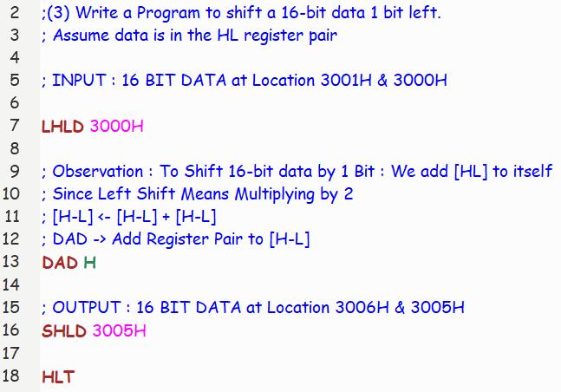

Registers and Memory:

|  |  |
| --- | --- |
| INPUT | EXPECTED OUTPUT |
| (20 05)H  [3000H] = 05H = (5) [Decimal]  [3001H] = 20H = (32) [Decimal]  (2005)H = (0010 0000 0000 0101)2 | After Shifting Left, By 1 Bit  (0100 0000 0000 1010)2 = (40 0A)H  [3005H] = 0AH = (10) [Decimal]  [3006H] = 40H = (64) [Decimal] |

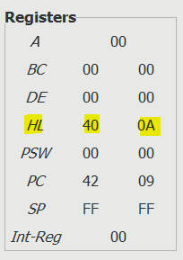 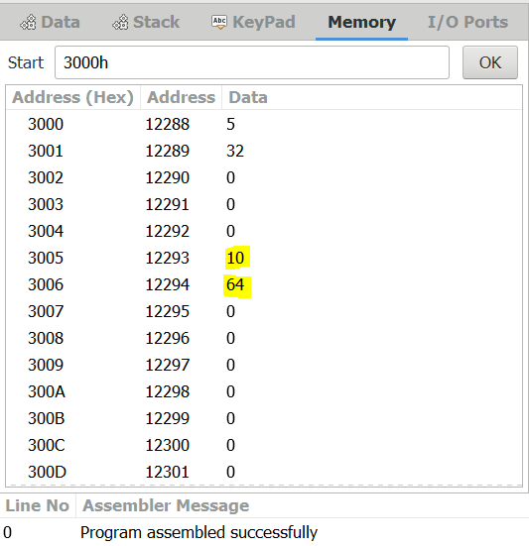

|  |  |
| --- | --- |
| INPUT | EXPECTED OUTPUT |
| (C5 E7)H  [3000H] = E7H = (231) [Decimal]  [3001H] = C5H = (197) [Decimal]  (2005)H = (1100 0101 1110 0111)2 | After Shifting Left, By 1 Bit  (1000 1011 1100 1110)2 = (8B CE)H  [3005H] = CEH = (206) [Decimal]  [3006H] = 8BH = (139) [Decimal] |

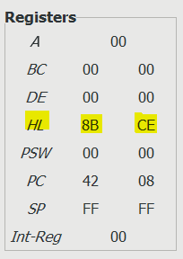 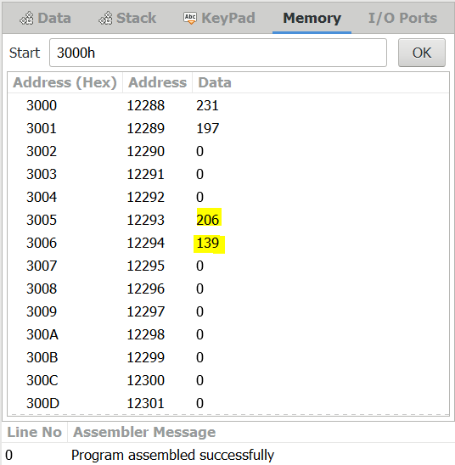

(4) Write a Program to calculate the factorial of a number between 0 to 8.

Notepad Code:

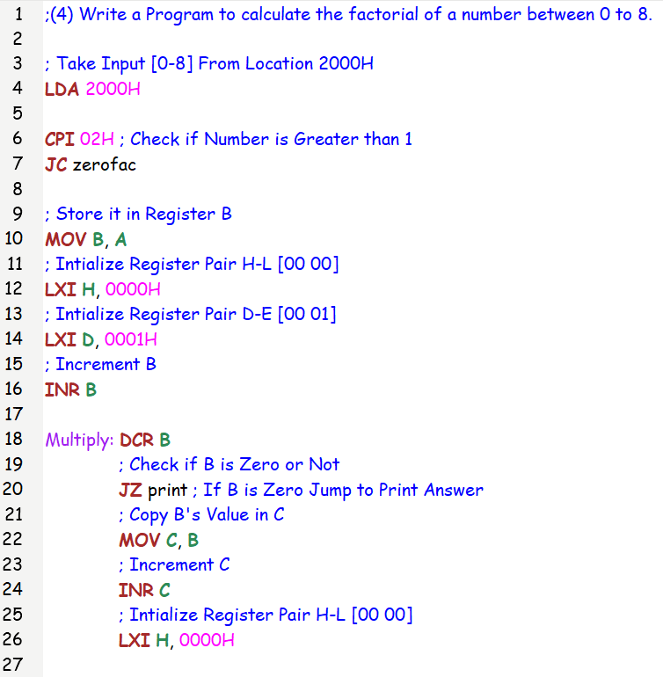

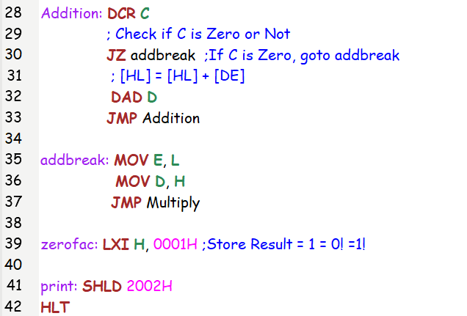

Registers and Memory:

|  |  |  |
| --- | --- | --- |
| Number (n) | Factorial (n!) [Decimal] | Factorial (n!) [Hexa-Decimal] |
| 0 | [0 1] | (00 01)H |
| 1 | [0 1] | (00 01)H |
| 2 | [0 2] | (00 02)H |
| 3 | [0 6] | (00 06)H |
| 4 | [0 24] | (00 18)H |
| 5 | [0 120] | (00 78)H |
| 6 | [2 208] | (02 D0)H |
| 7 | [19 176] | (13 B0)H |
| 8 | [157 128] | (9D 80)H |

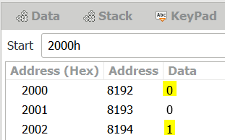 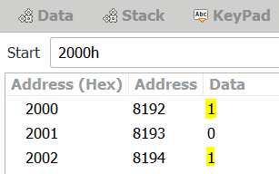 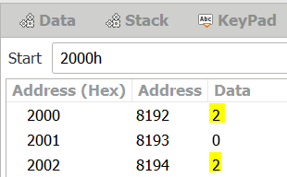

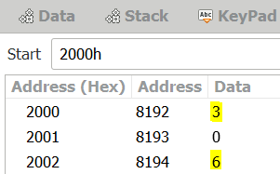 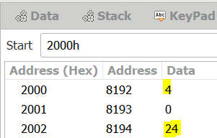 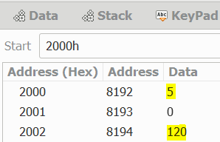

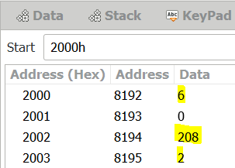 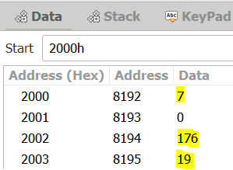 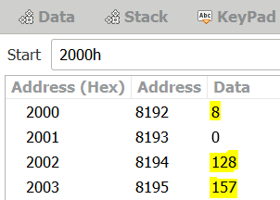

(5) Write a program to Split 8 bit HEX data into two nibbles and store it in memory.

Notepad Code:

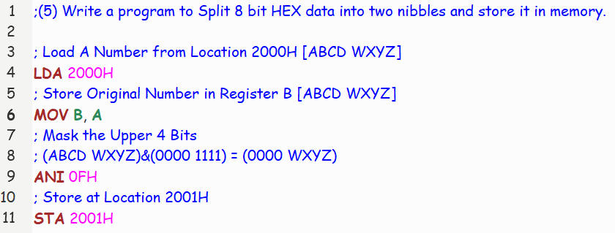

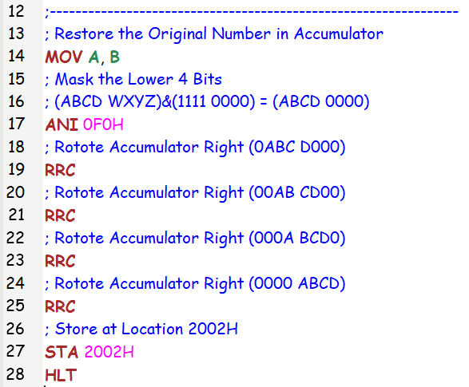

Registers and Memory:

|  |  |  |  |  |  |
| --- | --- | --- | --- | --- | --- |
| INPUT [(2000)H] | | OUTPUT1 [(2002)H] | | OUTPUT2[(2001)H] | |
| Hex | **Decimal** | **Hex** | **Decimal** | **Hex** | **Decimal** |
| (54)H | 84 | (05)H | 5 | (04)H | 4 |
| (A8)H | 168 | (0A)H | 10 | (08)H | 8 |
| (DA)H | 218 | (0D)H | 13 | (0A)H | 10 |

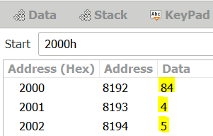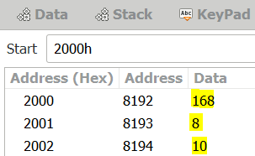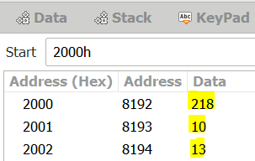

SUBMITTED BY: BHAGYA VINOD RANA [***U19CS012***]